Game Design Document

Fill up the following document

1. Write the title of your project.

The Mario Runner

1. What is the goal of the game?

To survive from the monsters

1. Write a brief story of your game.

You are Mario and the Monsters are in front of you who are going to kill you so

You have to dodge them and kill them. Before they kill you.

1. Which are the playing characters of this game?

* Playing characters are the ones who respond to the user based on the input from the user.
* Cars, monkeys, dinos, wizards, etc., are the playing characters in the game.

|  |  |  |
| --- | --- | --- |
| Number | Character Name | What can this character do? |
| 1 | Mario | He runs and shoots fireballs |
| 2 |  |  |
| 3 |  |  |
| 4 |  |  |
| 5 |  |  |
| 6 |  |  |
| 7 |  |  |
| 8 |  |  |

1. Which are the Non-Playing Characters of this game?

* Non-Playing characters are the ones that don't have an action or behavior when the user interacts with the game.
* Hurdles, stones, bananas, coins, etc., are non-playing characters in the game.

|  |  |  |
| --- | --- | --- |
| Number | Character Name | What can this character do? |
| 1 | Monsters | Moves and tries to kill the player |
| 2 | Clouds | - |
| 3 | Ground | Gives a platform to run on. |
| 4 |  |  |
| 5 |  |  |
| 6 |  |  |
| 7 |  |  |
| 8 |  |  |

Draw your imagination of this game. What does this game look like?

* Draw the game either on your computer or on paper.
* Add images of the game scenes to show each of the playing and non-playing characters at least once.

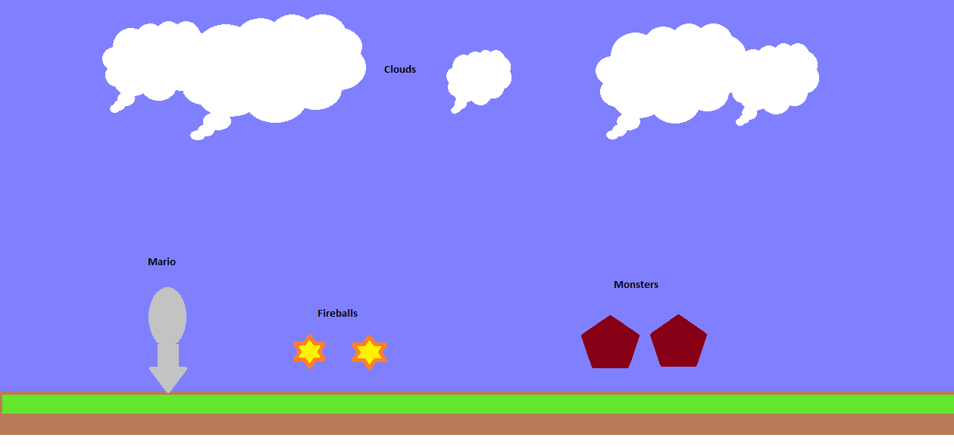

How do you plan to make your game engaging?

By adding sound effects By building up a scoring system